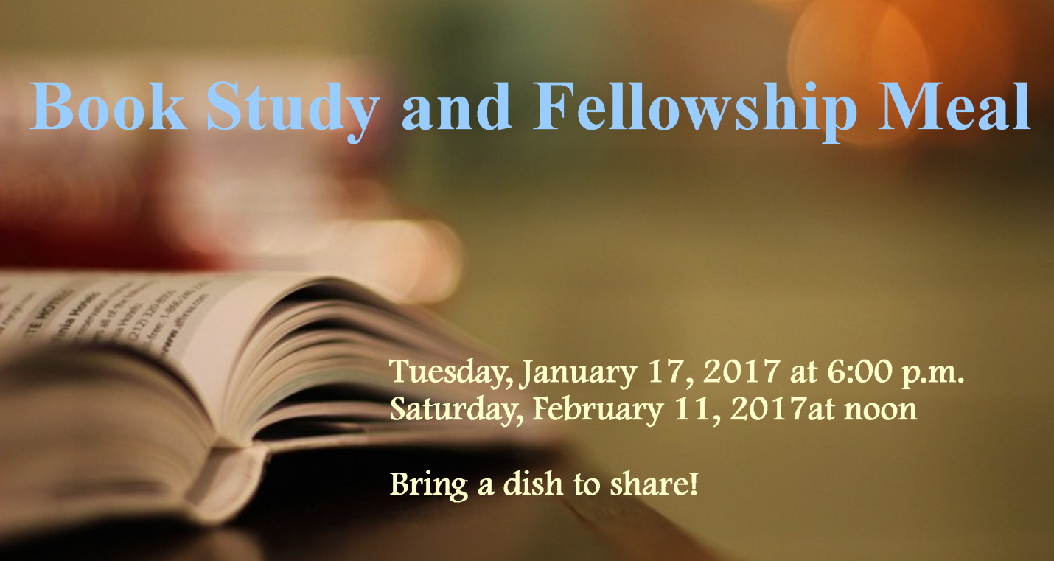
BOOK STUDY AND FELLOWSHIP MEAL
Book Study and Fellowship Meal

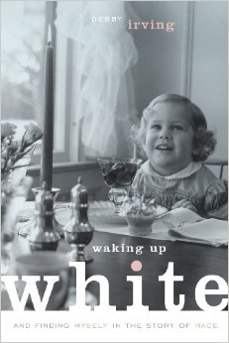
Presbyterian Church (USA) Co-Moderators, Rev. T. Denise Anderson and Rev. Jan Edmiston, have invited the denomination to read Debby Irving’s Waking up White and Finding Myself in the Story of Race and to engage in conversations about the often difficult topic of race and ethnicity. In our Presbytery we are responding to this invitation and also are seeking to build a community of open communication, mutual understanding and courageous disciples.
Rev. Ann Christensen, will lead two separate book discussions around fellowship meals (please bring an ethnic dish to share). The first discussion is on January 17, 2017 at 6:00 p.m., OR the second discussion is February 11, 2017, beginning at noon. Please save one of these dates and plan to attend what promises to be thought provoking dialogue!
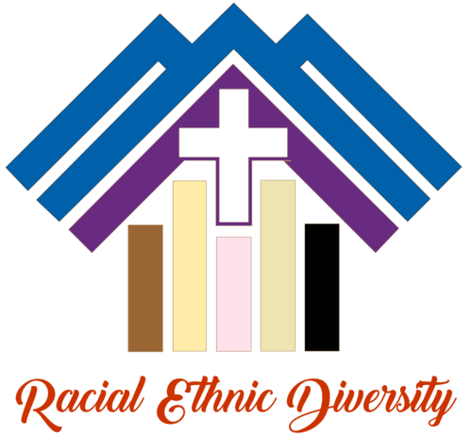
Additional information and registration will be available on the Presbytery www.denpres.org/events.
Books are available at The Thoughtful Christian.

Sponsored by: Racial Ethnic Diversity and Leadership Work Groups.

