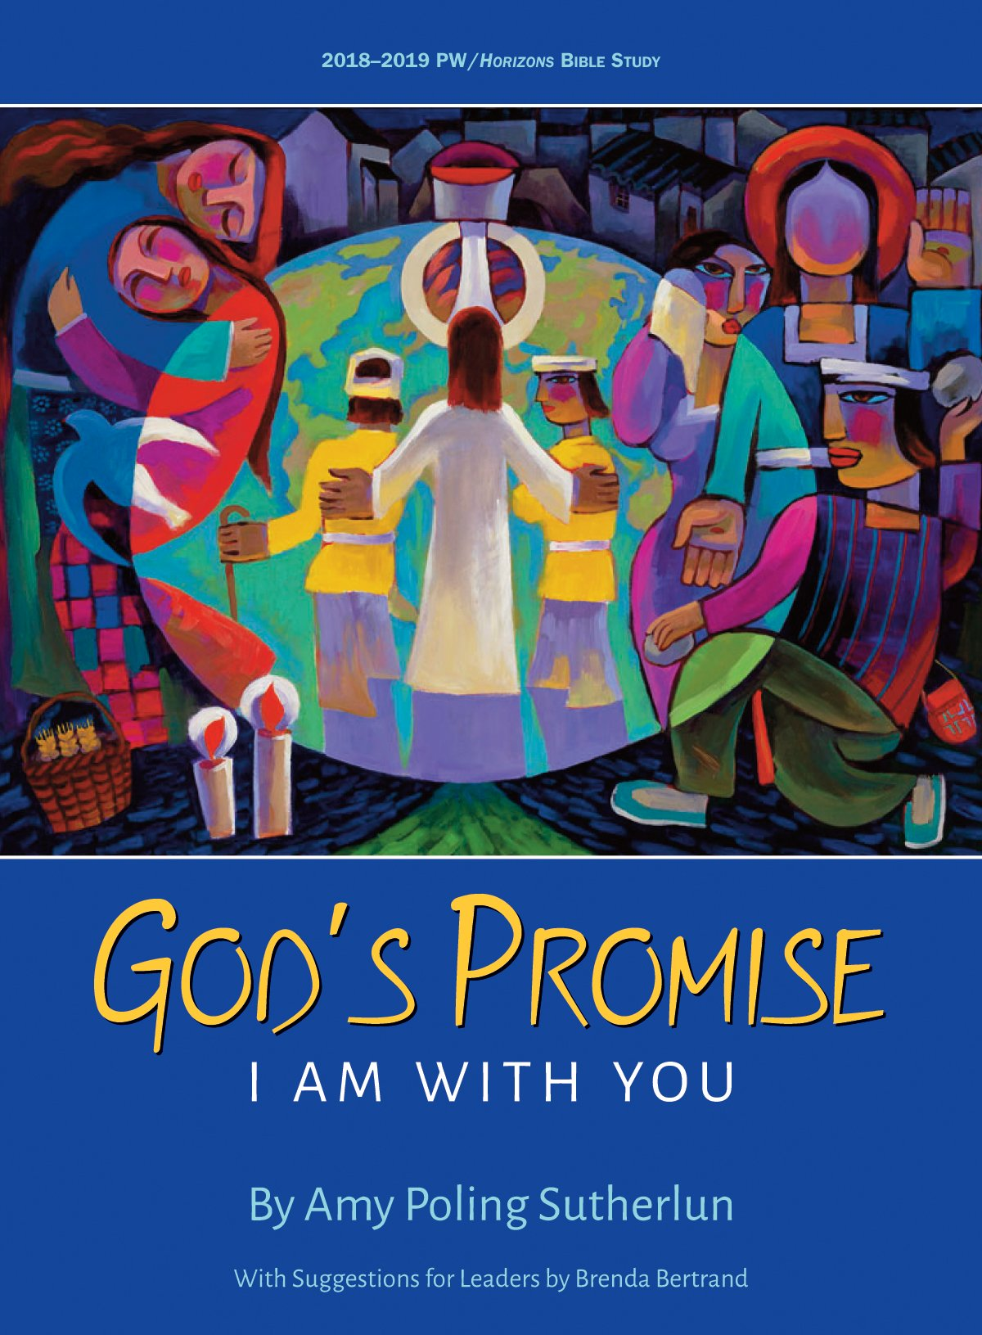
Bible Study Seminar 2018
Sat., August 18, 2018
Program & lunch $10
Registration 9:30 to 10 a.m.
Program 10 a.m. followed by lunch
Central Presbyterian Church
Presenter: Rev. Louise Westfall
Central Presbyterian Church is a historic church located between 16th and 17th Avenues at
1660 Sherman St, Denver, CO 80203

RSVP to Moderator Vicki Terry at (720) 273-6870‬ or sosagup@q.com by Wed., Aug. 15.‬

2018-2019 Horizons Bible Study God's Promise: I Am with You
By Amy Poling Sutherlun with Suggestions for Leaders by Brenda Bertrand
The 2018—2019 PW/Horizons Bible study, God’s Promise: I Am with You, takes readers on a journey through scripture to consider circumstances in which God articulated God’s promise of presence. We will see anew that God offered these words of profound comfort and commitment to individuals and communities from the time of the patriarchs to that of the prophets; from the judges to the kings; before, during, and after the exile; into the New Testament and beyond, to the end of the age.
To order: use the order form, go to www.presbyterianwomen.org/shop, or phone PC(USA) Store at 800-533-4371, M-F, 9 a.m. to 5 p.m. EST

Parking: All on-street parking in surrounding blocks is free on weekends. Handicap-accessible spaces are directly in front of the church. Many surface lots are available within 2 blocks of the church, including directly across the street: rates vary. Elderly and differently-abled individuals may park in the three staff parking spaces and the three handicap parking spaces in front of the church.
Street-level entrance and elevator are to the right of the steps & the main doors.

