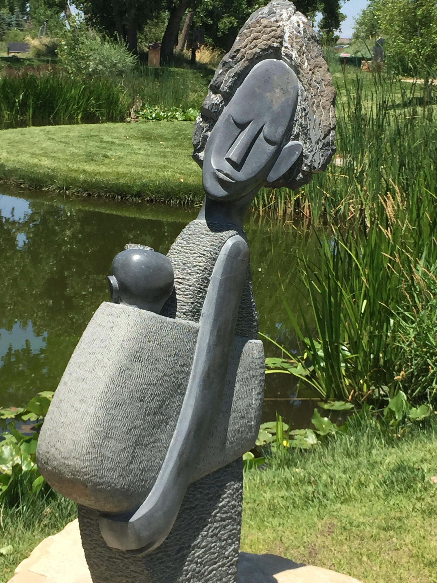
Chapungu Sculpture Park
Saturday, September 19, 2015, 8:30 a.m. to after lunch
Loveland, Colorado – Carpool from Presbytery Center or Good Shepherd Church, Northglenn.

Costs: Lunch in a nearby restaurant

R.S.V.P. Rev. Kim Graber at (303) 921-4292 or kimjgraber@gmail.com.

A sanctuary from the everyday, the 26-acre Chapungu (pronounced cha-poon-goo) Sculpture Park is the only permanent exhibit of its kind in the U.S. This public park features 82 African stone sculptures carved by artists from Zimbabwe. The artwork is positioned among water features, a 1.5 mile walking trail, and benches for rest and reflection. Bring your camera or a journal and enjoy this peaceful interlude on an autumn morning followed by lunch.

